BANKING SYSTEM IN C++
Name:Samsackson murithi mutiria
Registration number:CT202/113616/23
E-mail address:samsacksonmurithi31@gmail.com
Tel:254702014629
Project report:Banking system in C++
INTRODUCTION
- This programme in C++ facilitate the operations which can be performed by the bank personnel such as: Adding new customer account, edit existing customer account, list all customer details including their account number, able to generate daily and monthly business transactions report etc.
- Its user friendly graphical mode will made its users to work with this new system in more interactive way.
Objective:

- The main objective of this banking system which is developed in c++ is to provide a flexible solutions for banking industry.
- With this system both type of users such as bank customers and working personnel of the particular bank will find easy to use and able to perform all their operations using this system.
- This system enable its users to open and close the bank account. Customers will able to withdraw and deposit amount to their particular account.
- It will also able to generate transactions on money for particular customer account.

DESIGN
Banking
- New account
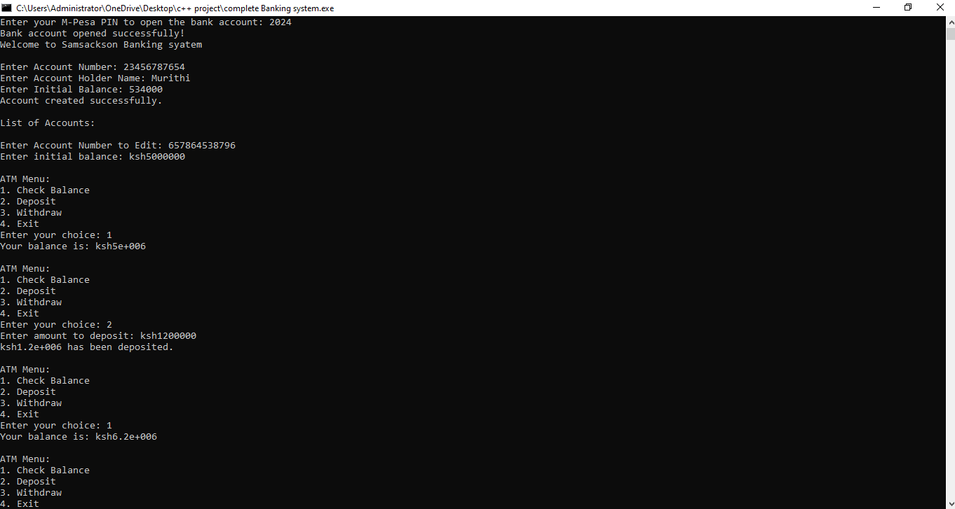
- List account
- Daily transitions
- Monthly report
- Edit account
- Exit
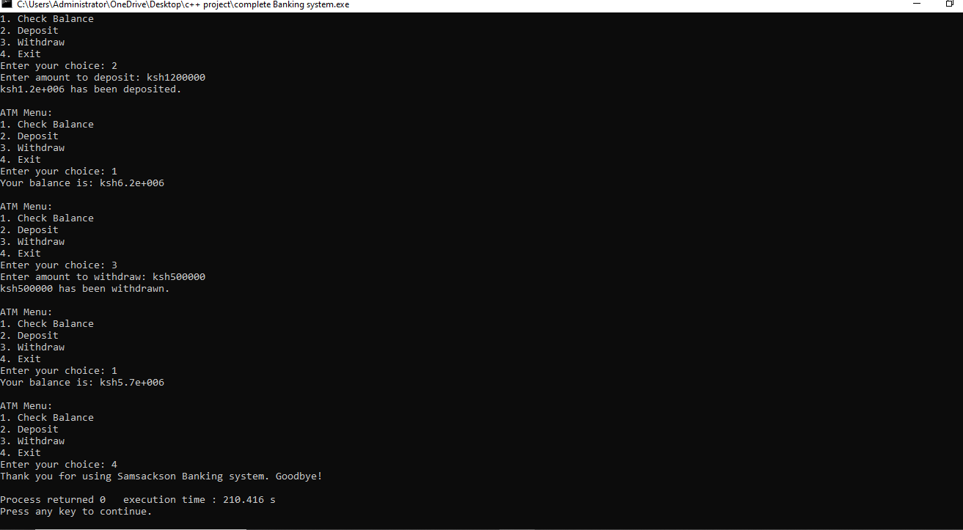

Implementation
- To perform operations such as adding customers account, a particular form will be appear under all fields should be entered correctly.
- If there will be any error while entering the data, system will not accept those values and its data will not be saved in the file.
- . Under this system, users are not able to generate transactions statement and this system was not developed in such a way that it can be used by their customers also.
- Under existing system, the concepts of graphics was not implemented and thus all processing was done by entering certain command which cannot be used by the end users and proper training given to the working personnel of the particular bank.

Conclusion
- This new system has the potential to perform all the activities which are required to make a successful bank.
- This interactive system will able to provide customers all the information just by single click.
- Even working personnel will also able to make their query and able generate results as per their requirement.
- This new system has unique authentication and validation which will identify the type of users and as per that, it will provide particular working screen for particular users by which confidentiality can be maintained and do not get prone to any errors

